**Bus Management System**

I have made a “Bus Management System” consisting of 4 tables of bus, passenger, trip and booking. The bus network has one or more buses. A bus has a model number, a unique registration number, and the capacity to take one or more passengers. A bus trip has a unique trip number, a departure station, a destination station, a departure datetime, an arrival datetime. Each trip is carried out by a single bus. A passenger has a first name, last name, and a unique passenger id. A bus is uniquely identified by its registration number, so I used it as the primary key. A trip is uniquely identified by its trip number, so I used it as the primary key of the trip table. The departure and destination are captured in the trip_from and trip_to attributes, and I have separate attributes for the departure and arrival date and time with datetime. Because no two passengers will share a passenger number, I used the passenger number as the primary key for the Passenger entity. Booking number is unique, that's why I used booking number as primary key in Booking entity. Here the passenger no is a foreign key from the passenger table. A Bus can be involved in any number of trips, while each trip uses exactly one bus, so the trip relationship between the bus and trip relationship has cardinality because a trip cannot exist without a bus. A passenger can book any number of flights, while a flight can be booked by any number of passengers.

**ER Diagram:**

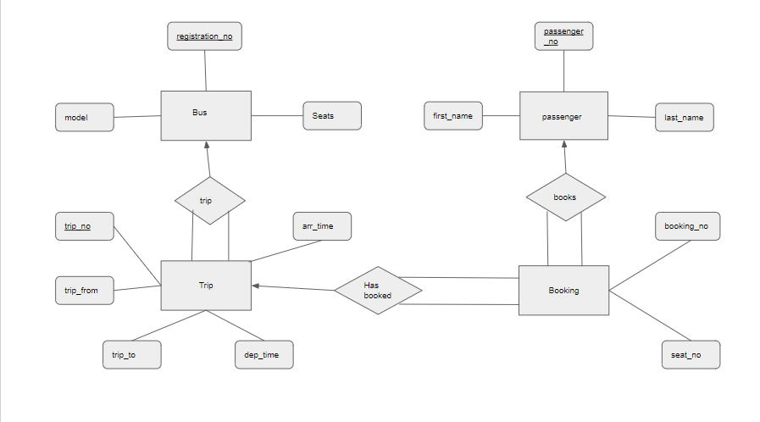

**Schema Diagram:**

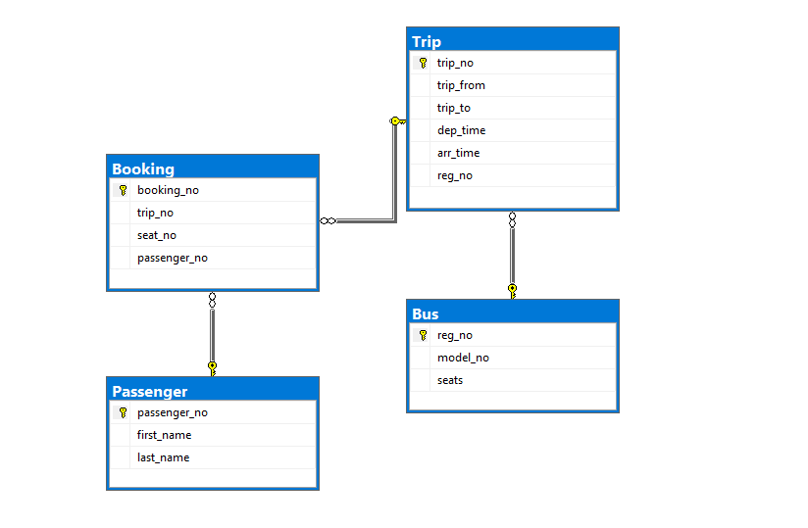

**Data Insertion:**

1. Bus table

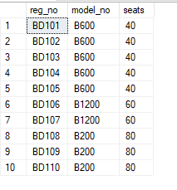

1. Trip Table

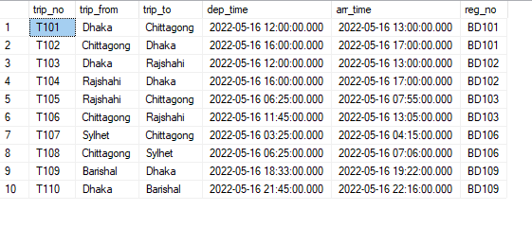

1. Booking Table

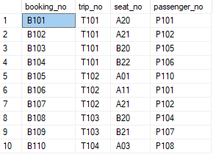

1. Passenger Table

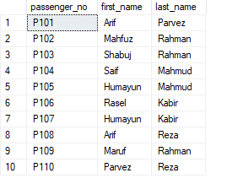

**Queries:**

1. **List all trips from Dhaka containing trip_no, destination, departure time, arrival time and registration numbers of the bus.**

Query: SELECT trip_no,trip_to,dep_time,arr_time,reg_no FROM dbo.Trip WHERE trip_from = 'Dhaka';

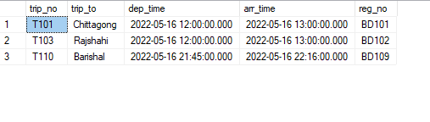

1. **How many trips departs from Dhaka?**

**Query: SELECT COUNT(DISTINCT trip_no) FROM dbo.Trip WHERE trip_from = 'Dhaka';**

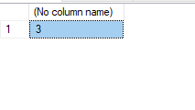

1. **List all the trips departing from Dhaka 5th (5am) to 20th (8pm) order by departing time.**

**Query: SELECT * FROM dbo.Trip WHERE trip_from = 'Dhaka' and dep_time between '2022-05-16 05:00:00.000' and '2022-05-16 20:00:00.000' order by dep_time;**

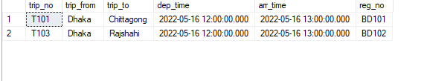

1. **Provide the name of all the passenger and their seat number.**

**Query: SELECT p.first_name + p.last_name as PassengerName, b.seat_no from Passenger p INNER JOIN Booking b ON b.passenger_no = p.passenger_no;**

